# **Name: Abdurrahman Qureshi**

# **Roll No: 242466**

Practical No: 2

**1) Draw a circle in python via Turtle**

CODE:

import turtle

canvas = turtle.Screen()

gt = turtle.Turtle()

for i in range(40):

gt.forward(25)

gt.left(10)

OUTPUT:

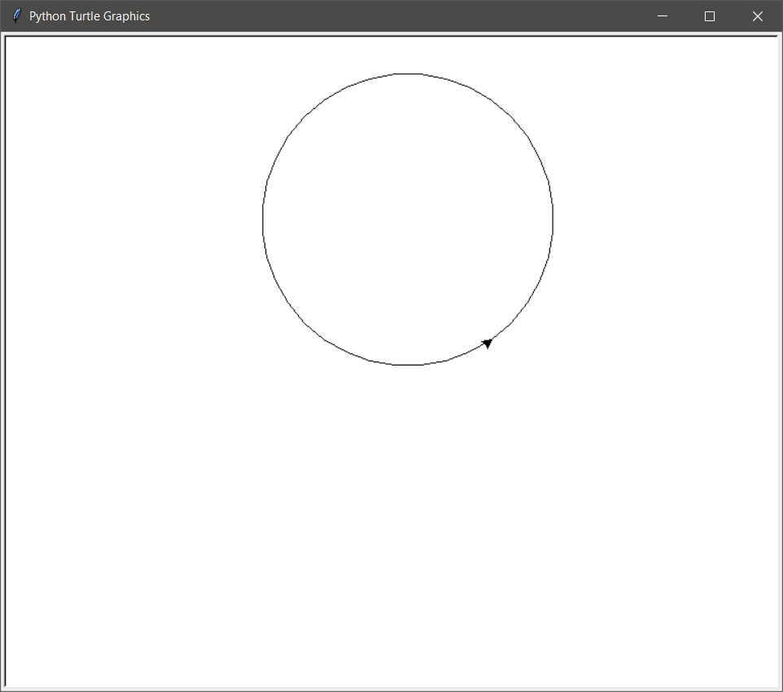

**2) Draw a filled circle in python via Turtle**

CODE:

import turtle

pen = turtle.Turtle()

pen.begin_fill()

pen.fillcolor("purple")

pen.circle(50)

pen.end_fill()

turtle.done()

OUTPUT:

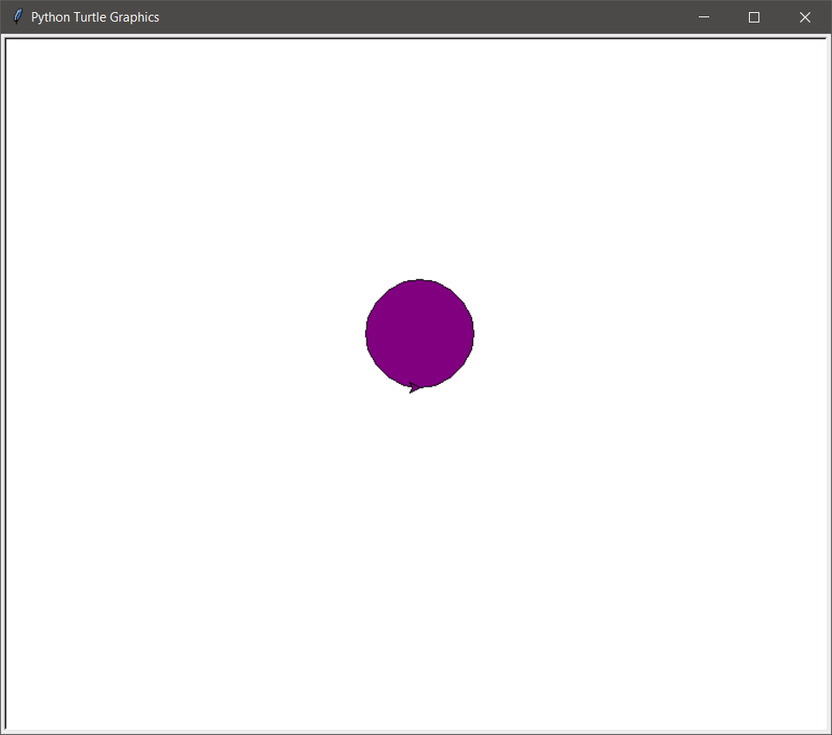

**3) Draw nested circles in python via Turtle**

CODE:

import turtle

canvas = turtle.Screen()

pen = turtle.Turtle()

for i in range(5):

for j in range(40):

pen.forward(10)

pen.left(10)

pen.forward(-25)

pen.done()

OUTPUT:

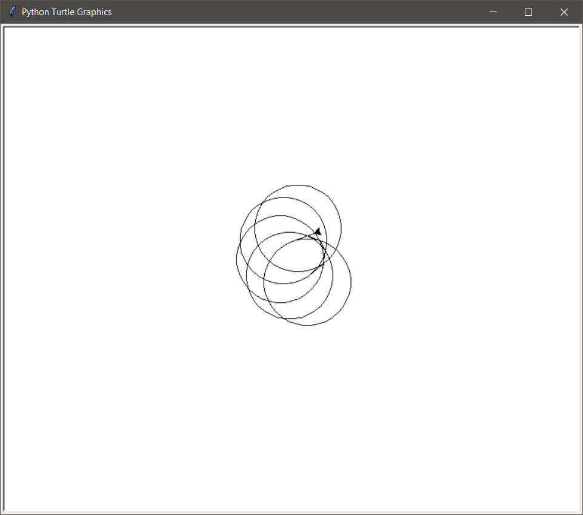

**4) Draw rectangle without loop in python via Turtle**

CODE:

import turtle

pen = turtle.Turtle()

pen.left(90)

pen.fd(100)

pen.right(90)

#pen.left(90)

pen.fd(200)

pen.right(90)

#pen.left(90)

pen.fd(100)

pen.right(90)

#pen.left(90)

pen.fd(200)

pen.right(90)

OUTPUT:

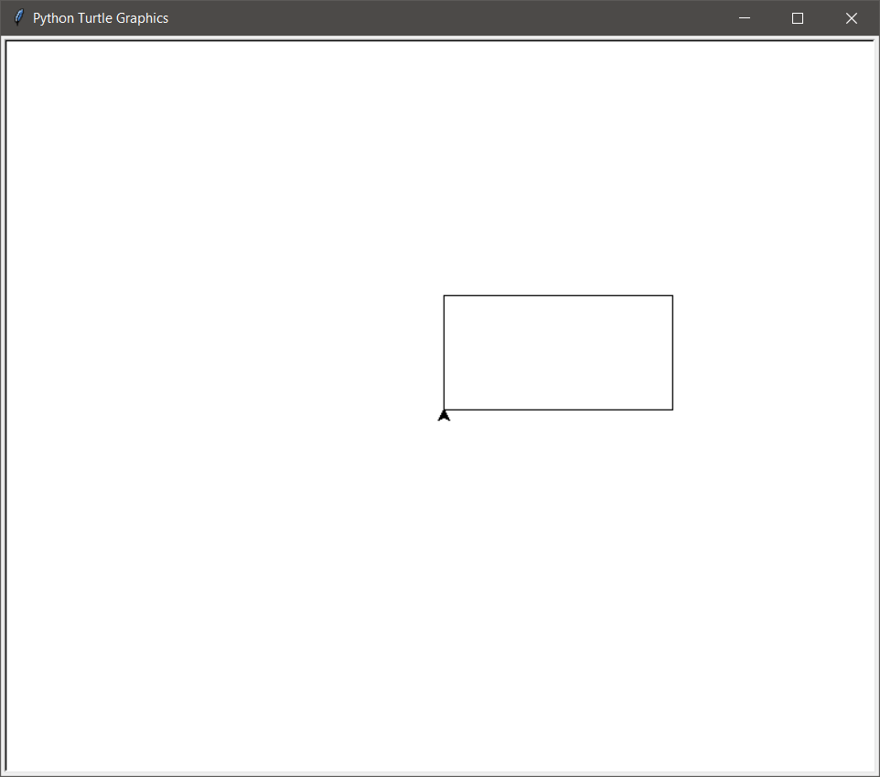

**5) Draw rectangle with loop in python via Turtle**

CODE:

import turtle

pen = turtle.Turtle()

for i in range(2):

pen.fd(100)

pen.right(90)

pen.fd(200)

pen.right(90)

OUTPUT:

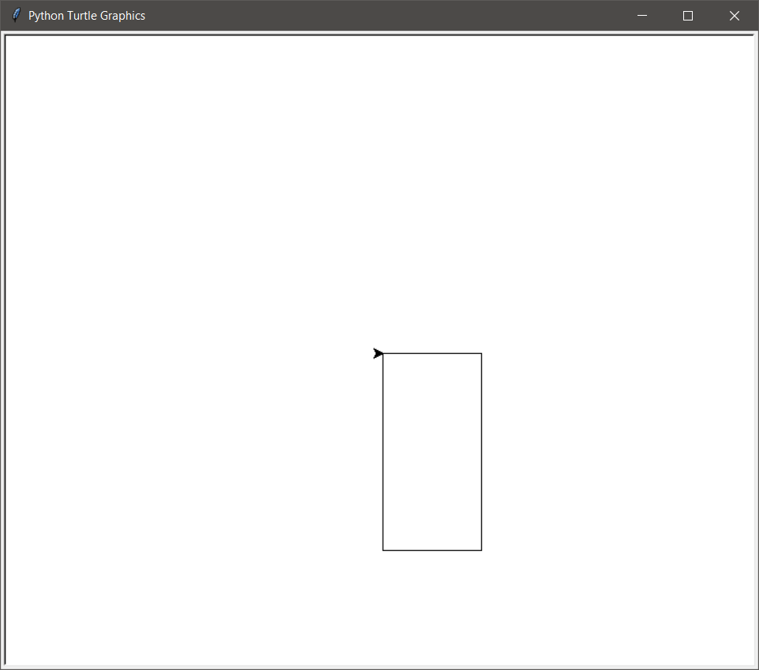

**7) Draw pattern using shapes of Pentagon ,Hexagon ,Octagon , Nonagon and Decagon in python Turtle**

Pentagon - CODE:

import turtle

import random

x = turtle.Turtle()

colors = ["red", "green", "yellow", "blue", "purple", "black"]

x.pensize(5)

for i in range(6):

x.color(colors[i])

for j in range(5):

x.forward(90)

x.left(72)

x.forward(90)

x.right(72)

turtle.done()

OUTPUT:

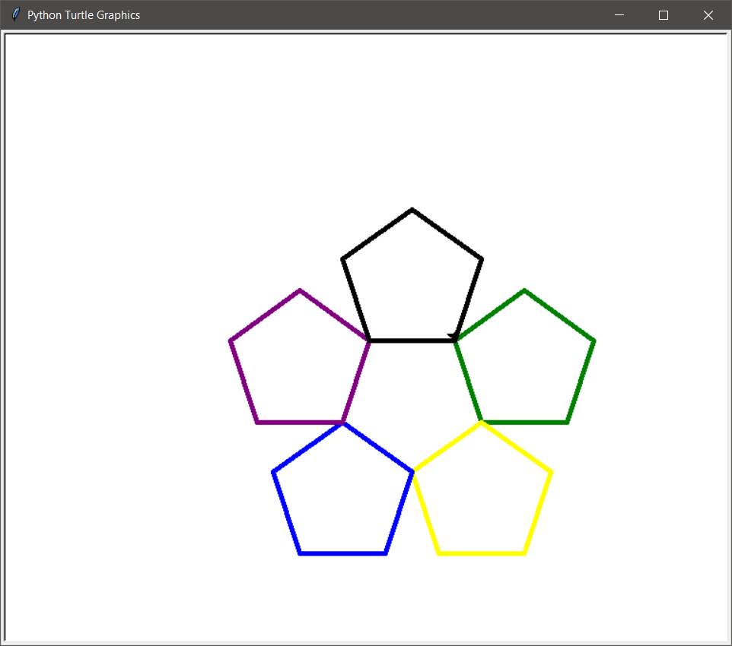

Hexagon - CODE:

import turtle

import random

x = turtle.Turtle()

colors = ["red","green","yellow","blue","purple","black"]

x.pensize(5)

for i in range(6):

for j in range(6):

x.forward(90)

x.left(60)

x.color(colors[i])

x.left(60)

x.forward(100)

OUTPUT:

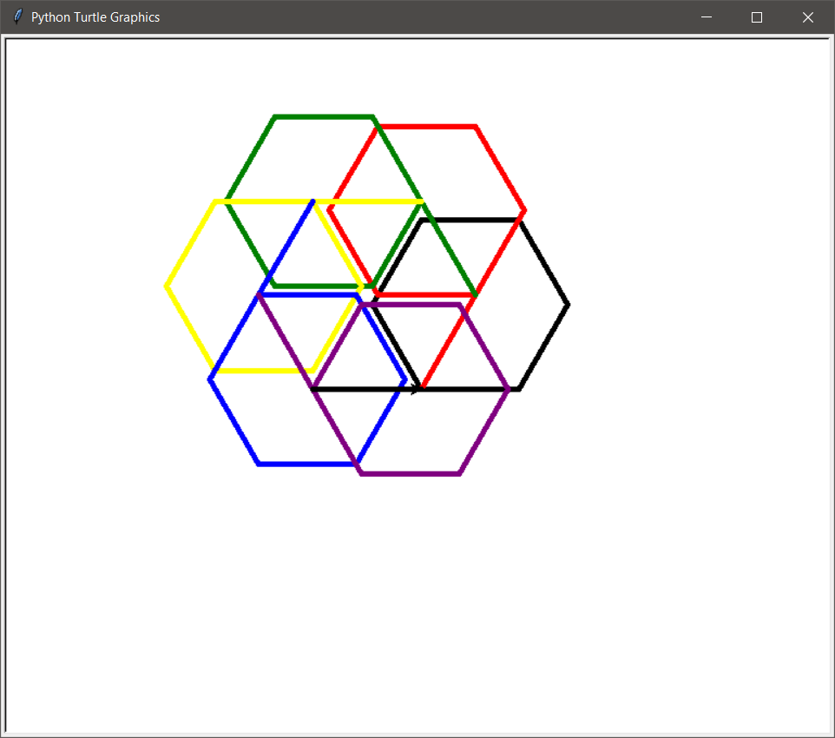

Octagon - CODE:

import turtle

import random

x = turtle.Turtle()

colors = ["red","green","yellow","blue","purple","black"]

x.pensize(5)

for i in range(6):

for j in range(6):

x.forward(90)

x.left(60)

x.color(colors[i])

x.left(60)

x.forward(100)

OUTPUT:

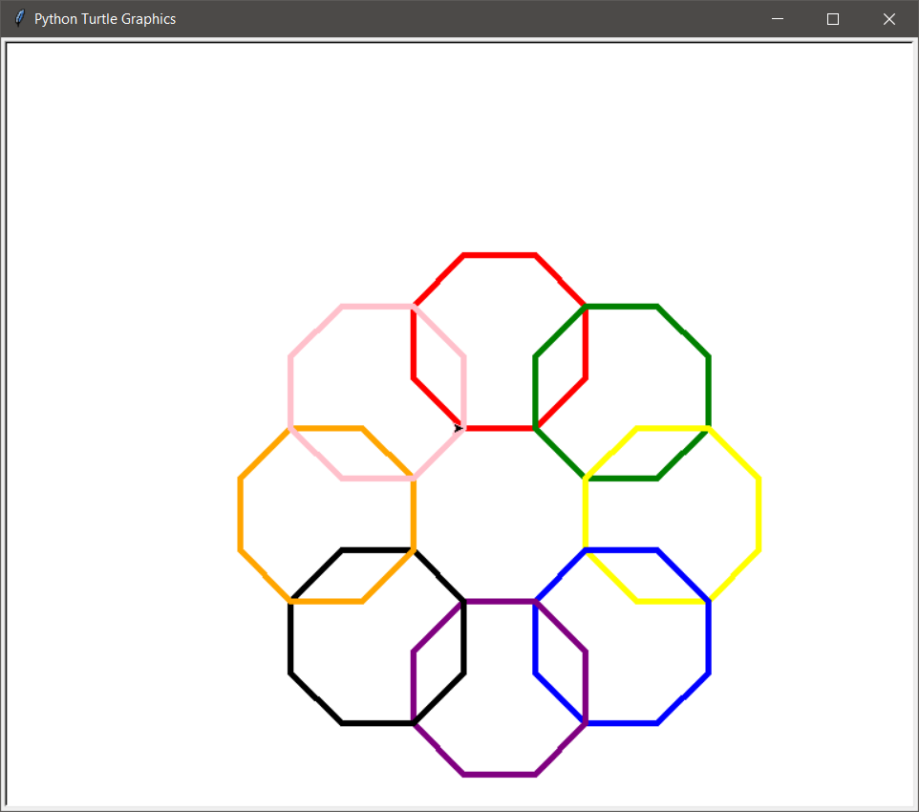

Nonagon - CODE:

import turtle

x = turtle.Turtle()

colors = ["red", "green", "yellow", "blue", "purple", "black", "orange", "pink", "blue"]

x.pensize(5)

x.speed(1000)

for i in range(10):

x.pencolor(colors[i])

for j in range(9):

x.forward(60)

x.left(40)

x.forward(60)

x.right(40)

turtle.done()

OUTPUT:

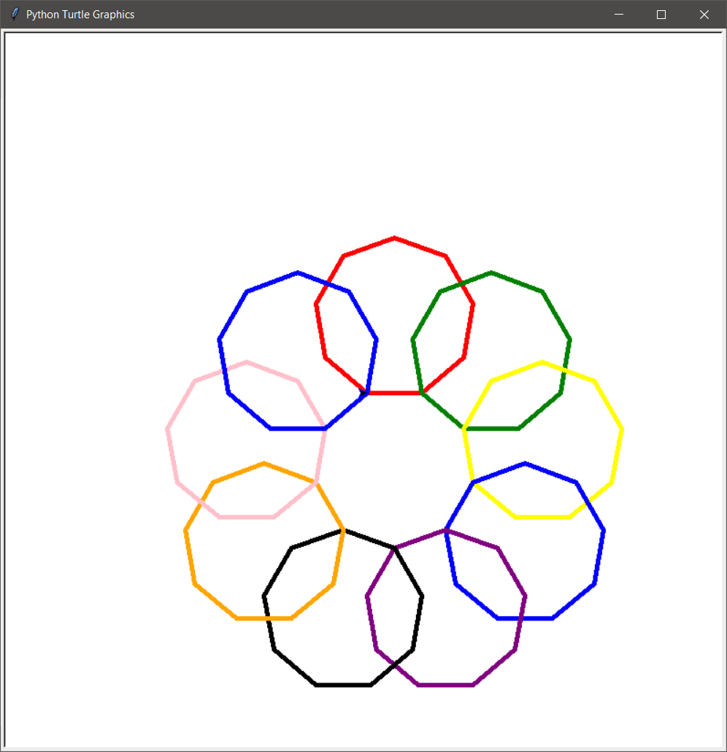

Decagon - CODE:

import turtle

x = turtle.Turtle()

colors = ["red", "green", "yellow", "blue", "purple", "black", "orange", "pink", "blue", "purple"]

x.pensize(5)

x.speed(1000)

for i in range(10):

x.pencolor(colors[i])

for j in range(10):

x.forward(38)

x.left(36)

x.forward(90)

x.right(36)

turtle.done()

OUTPUT:

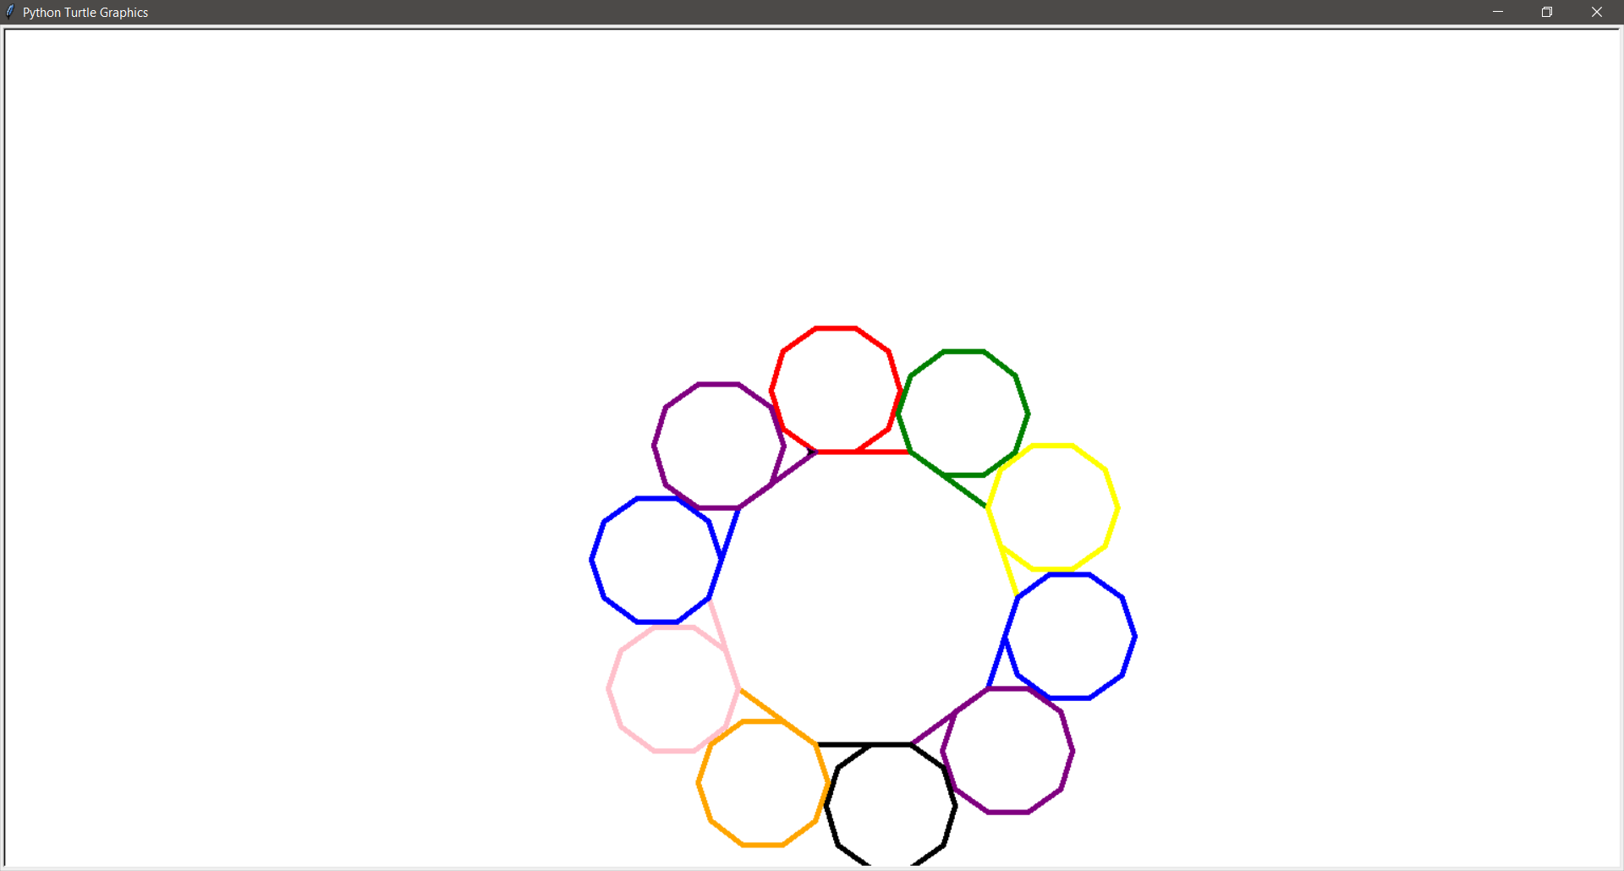

**8) What is the output of programs TurSpirography.py and turSpiral.py uploaded on G class room [ Explain the code in your own words]**

SPIRAL - CODE:

import turtle,random # importing modules turtle and random

t = turtle.Turtle() # creating an instance of turtle

t.pensize(5) # making the pen size thicker

t.speed(10000) # increasing the drawing speed

for i in range (5): # this will make circles with all colors of the list

for col in ['red','magenta','blue','yellow','green','purple','cyan','pink']:

# number of elements in the list means how many circles to draw

t.color(col) # assigning the pen color

t.circle(100) # drawing the circle

t.left(10) # moving the pen left by 10 coordinates

turtle.done()

OUTPUT:

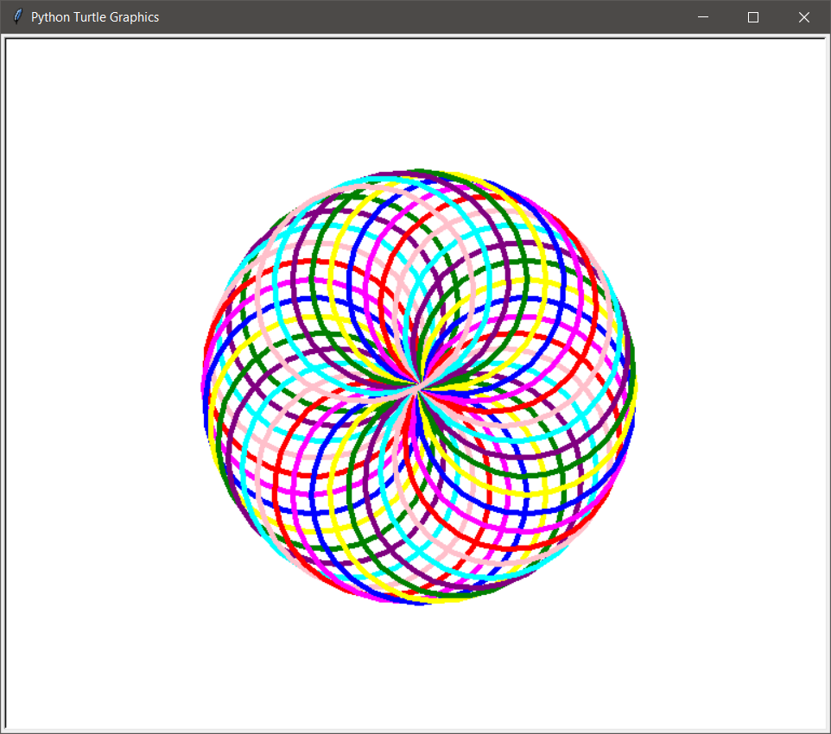

SQUARE - CODE:

import turtle,random # importing modules turtle and random

t = turtle.Turtle() # creating an instance of turtle

t.pensize(5) # setting the pen size

t.speed(500) # increasing the drawing speed

n=10 # factor on how many lines to draw

col =['red','magenta','blue','yellow','green','purple','cyan','pink']

# colors of lines

for i in range (n*4): # runs till factor * n

t.color(random.choice(col)) # choosing a color for the lines

t.fd(i*10) # drawing the line

t.rt(90) # rotating to right by 10

turtle.done()

OUTPUT:

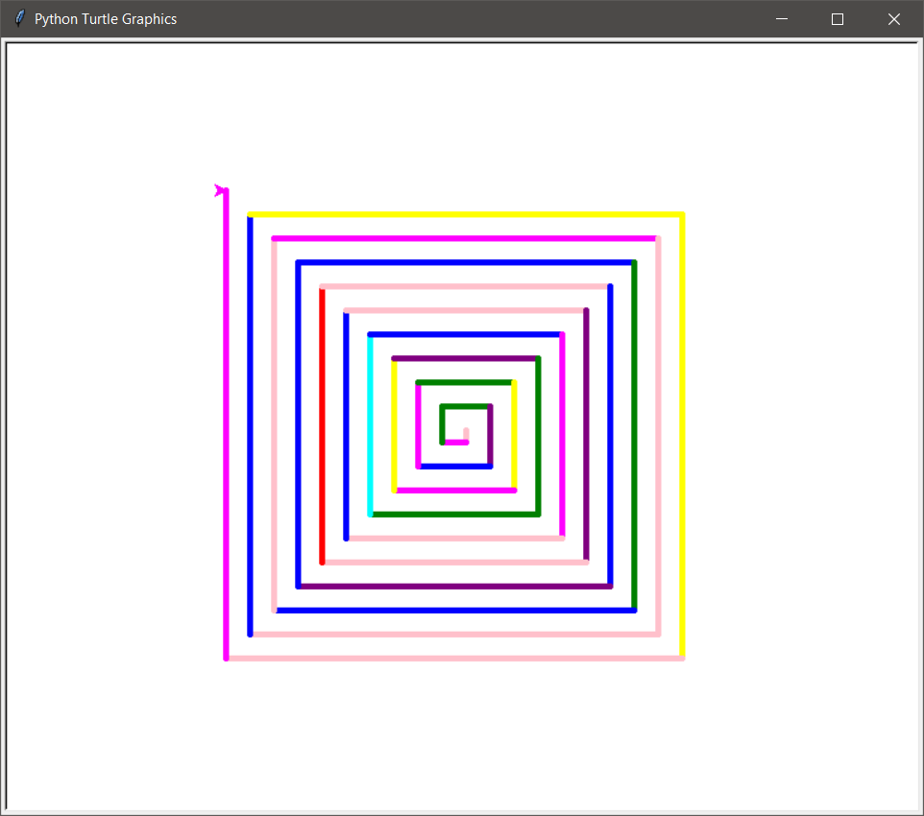

**9) Generate any one pattern of your choice using python turtle**

CODE:

import turtle

import random

x = turtle.Turtle()

colors = ["red","green","yellow","blue","purple"]

x.pensize(5)

for i in range(6):

for j in range(6):

x.forward(50)

x.left(60)

x.color(random.choice(colors))

x.left(60)

x.forward(100)

OUTPUT:

